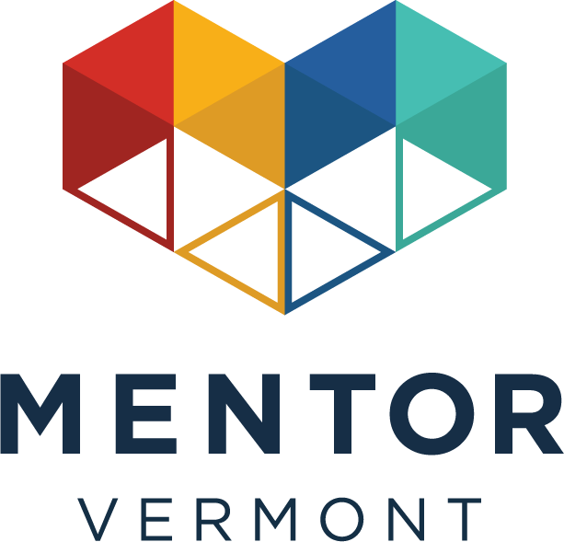

Youth Wellness and Mental Health

Training Facilitation Guide

Slide Deck

Participant Handout

Course Title: Youth Wellness and Mental Health

Background: Mentor Vermont is committed to ensuring that volunteer mentors feel confident, supported, and prepared to build safe, trusting relationships with youth. Many mentors enter their role with deep care and commitment, but without formal training in youth mental health or trauma-informed practices.
As youth across Vermont face increasing mental health challenges—including anxiety, stress, family instability, and social pressures—mentors are uniquely positioned to serve as protective factors in young people’s lives.
This training provides foundational knowledge and practical tools to help mentors recognize signs of distress, respond with empathy, maintain boundaries, and seek support appropriately.

Problem: While mentors are deeply committed, program feedback and national mentoring trends suggest:
- Mentors often feel unsure how to respond when youth share emotional concerns.
- Some mentors fear “saying the wrong thing.”
- There can be confusion about the difference between supporting and diagnosing.
- Boundary-setting can feel uncomfortable without guidance.
- Mentors may hesitate to escalate concerns to a Program Coordinator.

Without training, mentors may unintentionally:
- Minimize youth experiences
- Offer advice too quickly
- Miss signs of emotional distress
- Take on concerns beyond their role
This creates risk for both youth and mentors.

Organizational Goals:
Mentor Vermont’s overarching goal is to:
Ensure every mentor is equipped to create emotionally safe, trauma-informed mentoring relationships.

Specific Goals with Metrics:
- Increase mentor confidence in responding to youth emotional concerns (post-training survey target: 85% confidence rate).
- Improve appropriate reporting/escalation when safety concerns arise.
- Strengthen mentor retention by reducing anxiety around “handling it wrong.”
- Enhance youth-reported sense of emotional safety within mentoring relationships.

Training Goals:
By the end of this training, mentors will:

Recognize
Identify common signs of youth emotional distress without diagnosing.

2. Respond
Use trauma-informed communication strategies (The 4 R’s framework).

3. Demonstrate Active Listening
Apply empathy-based responses that build trust.

4. Maintain Boundaries
Understand the role of a mentor as a trusted adult—not a therapist.

5. Seek Support
Know when and how to involve a Mentor Program Coordinator.

Format: The training will be conducted as an in person ILT session.

Delivery: The training will be delivered in person. The facilitator will use a presentation to create an engaging learning experience.

Room Setup:
- Materials: Presentation slides covering the topic of Youth Wellness and Mental Health
- Feedback forms for participants to fill out at the end of the session.

Remember to communicate all the technical requirements and materials to the participants in advance so that they are well-prepared for the training.

Slide | Setup | Materials | Script
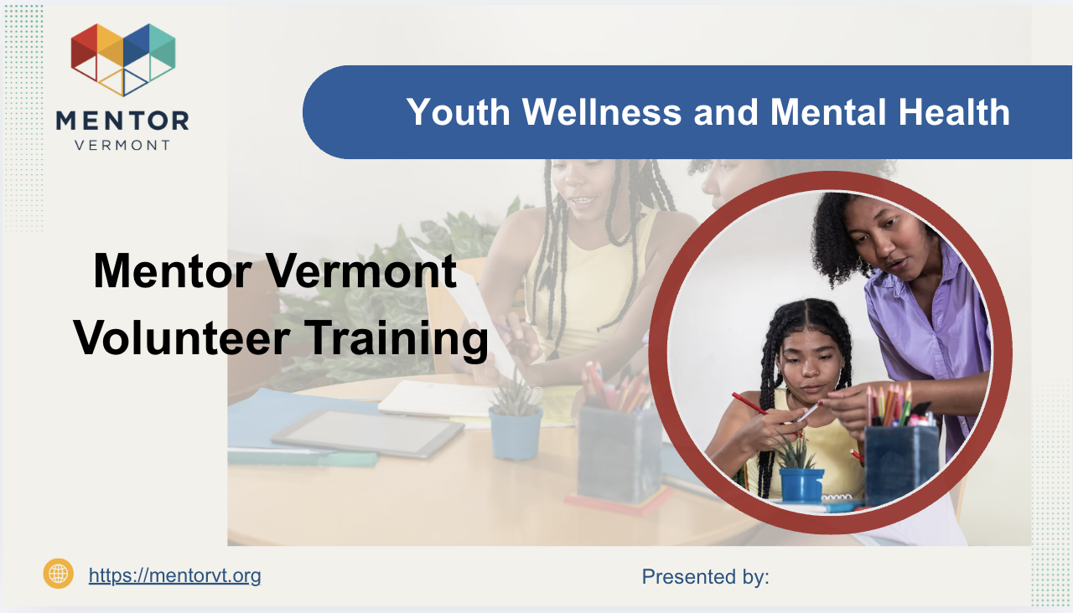 | Laptop, Projector | Presentation slides, Facilitator Guide, Participant Guides | “Good morning/afternoon everyone! Welcome to Youth Wellness and Mental Health Training. I’m [Name], and I’ll be your facilitator today. Before we begin, take a moment to introduce yourself in the chat or to a partner — your name and what inspired you to become a mentor.”
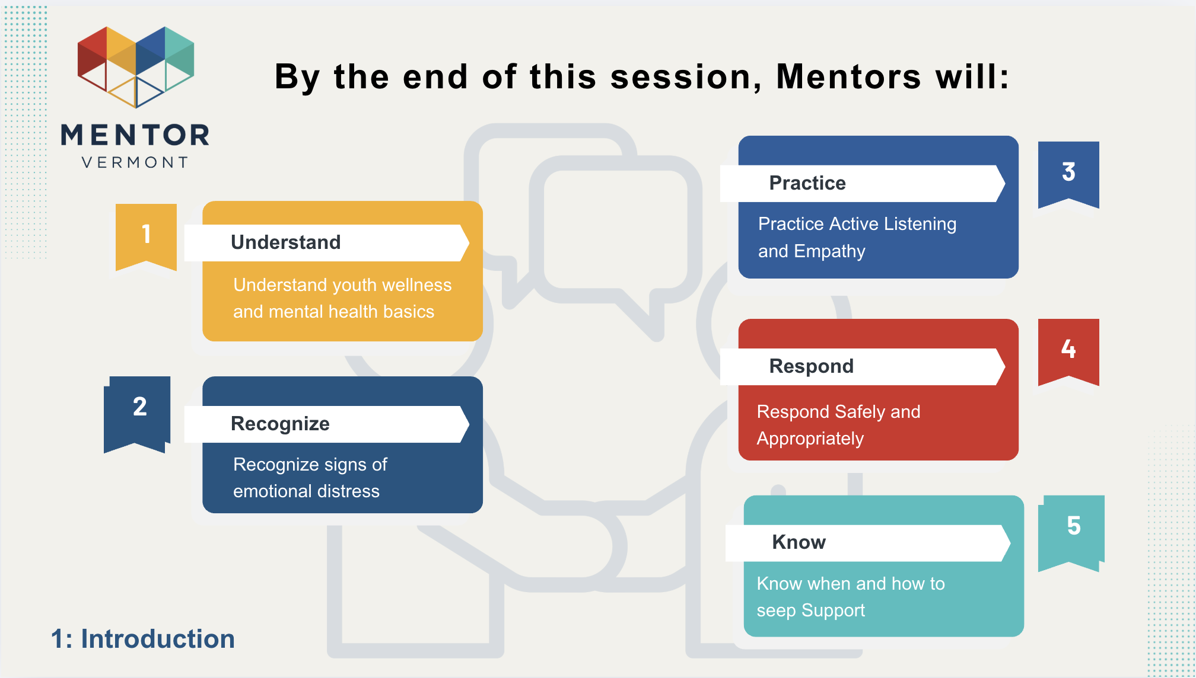 |  | Presentation slides & Agenda | “Today we’ll explore youth wellness, recognizing distress, practicing active listening, and responding safely as mentors, as well as how and when to seek support..”
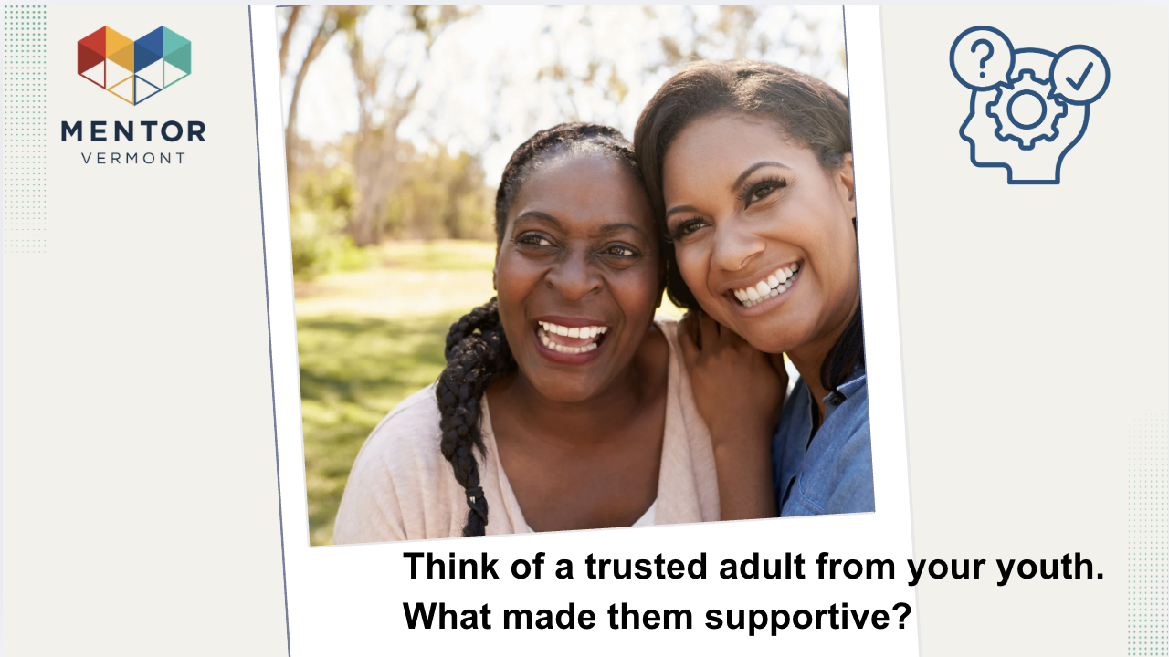 |  | Presentation Slides | “Think of a trusted adult from your youth. What made them supportive? Share one word or a few words with the person sitting next to you.”
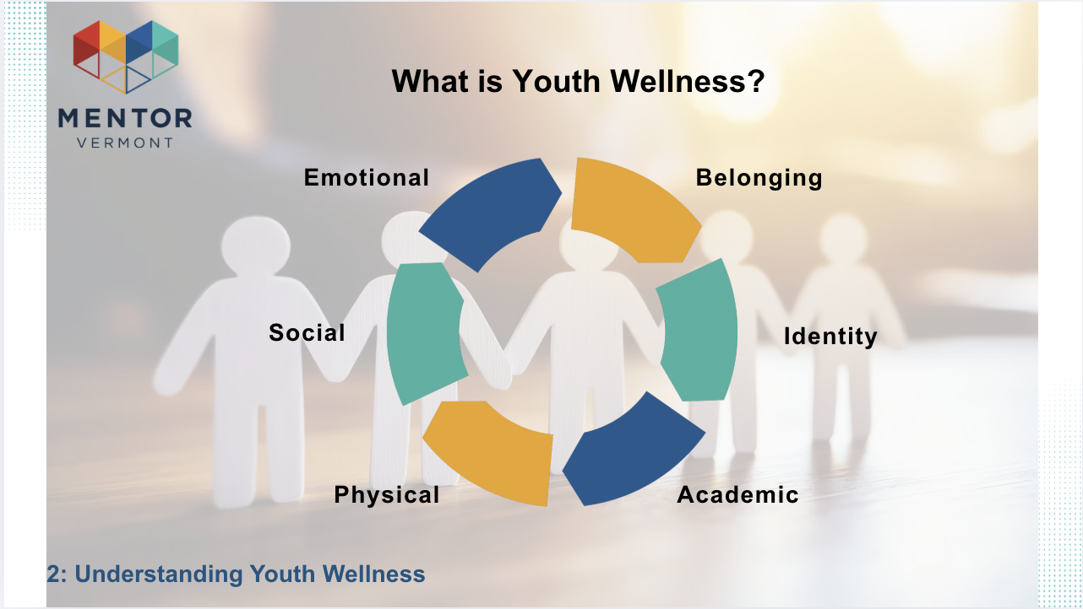 |  | Presentation slides | “Wellness is holistic — emotional, social, physical, academic, and identity needs are all interconnected.”
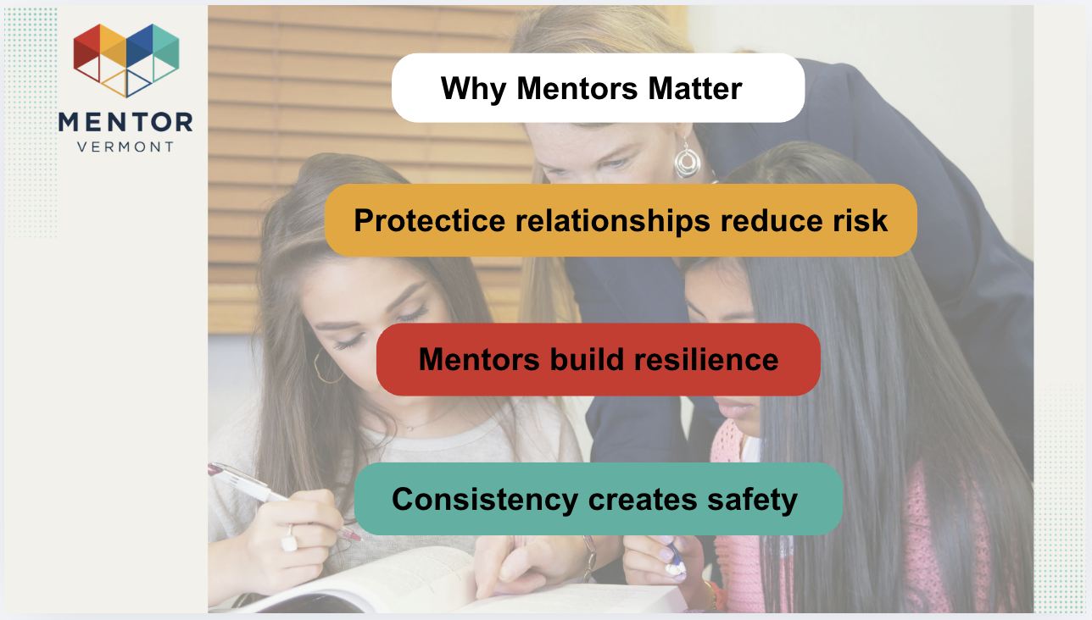 |  | Presentation slides | “Research shows one caring adult can significantly improve youth resilience and belonging.”  Facilitator tip:  * Share real mentoring impact example
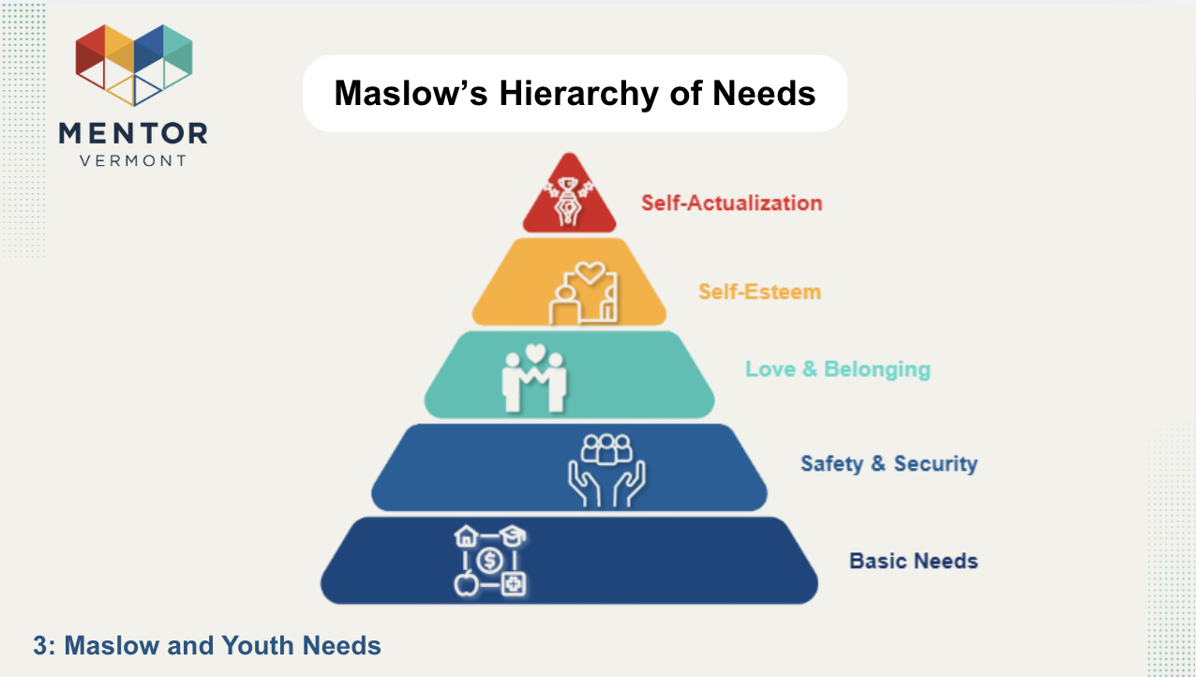 |  | Presentation Slides | “When basic needs aren’t met, higher emotional growth is difficult.”
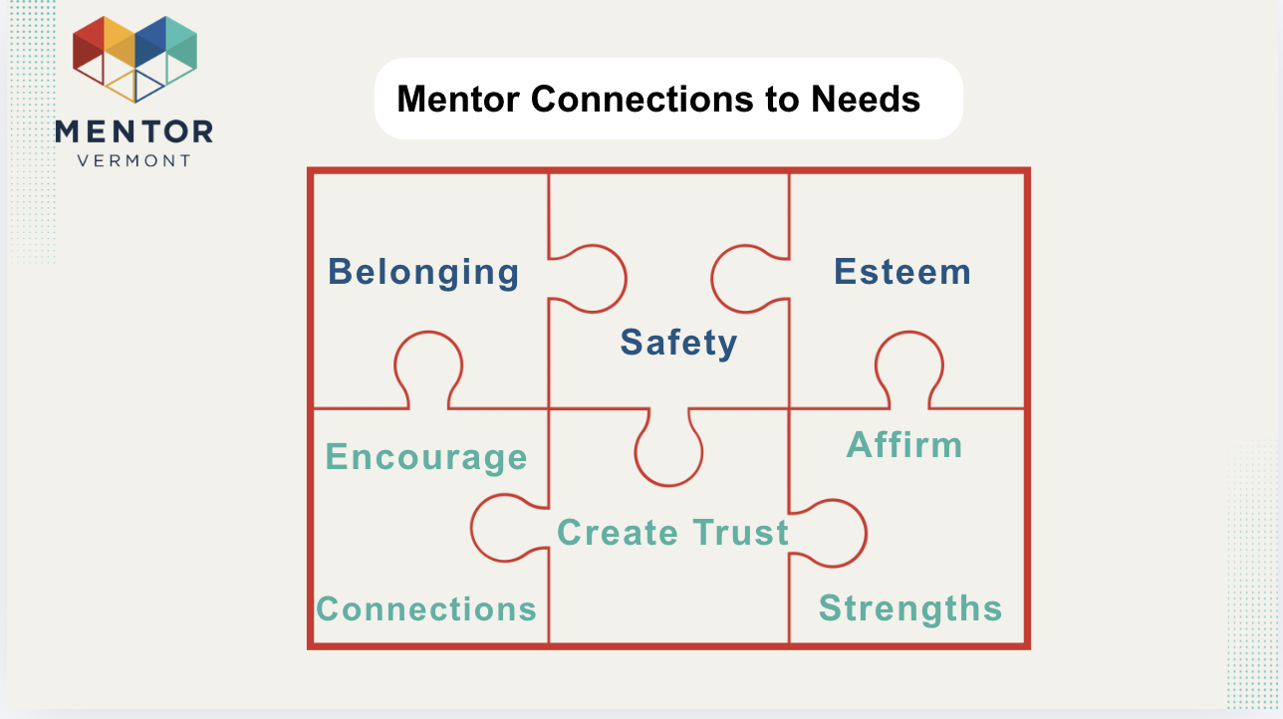 |  | Presentation slides | “Mentors don’t meet every need — but they can strengthen belonging, safety, and confidence.”
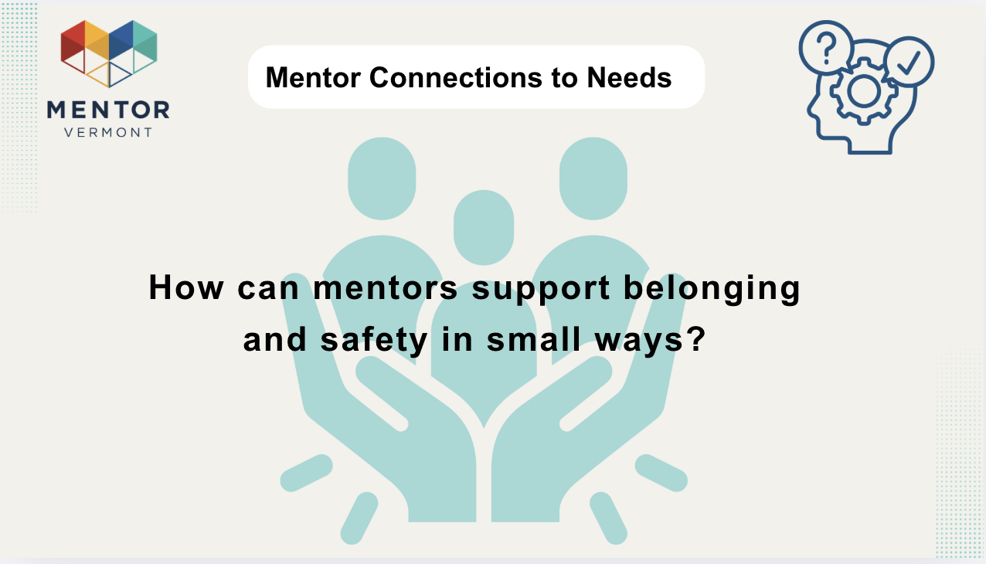 |  | Presentation slides | Ask:  “What small actions build belonging and safety?”  Examples: remembering interests, showing up consistently
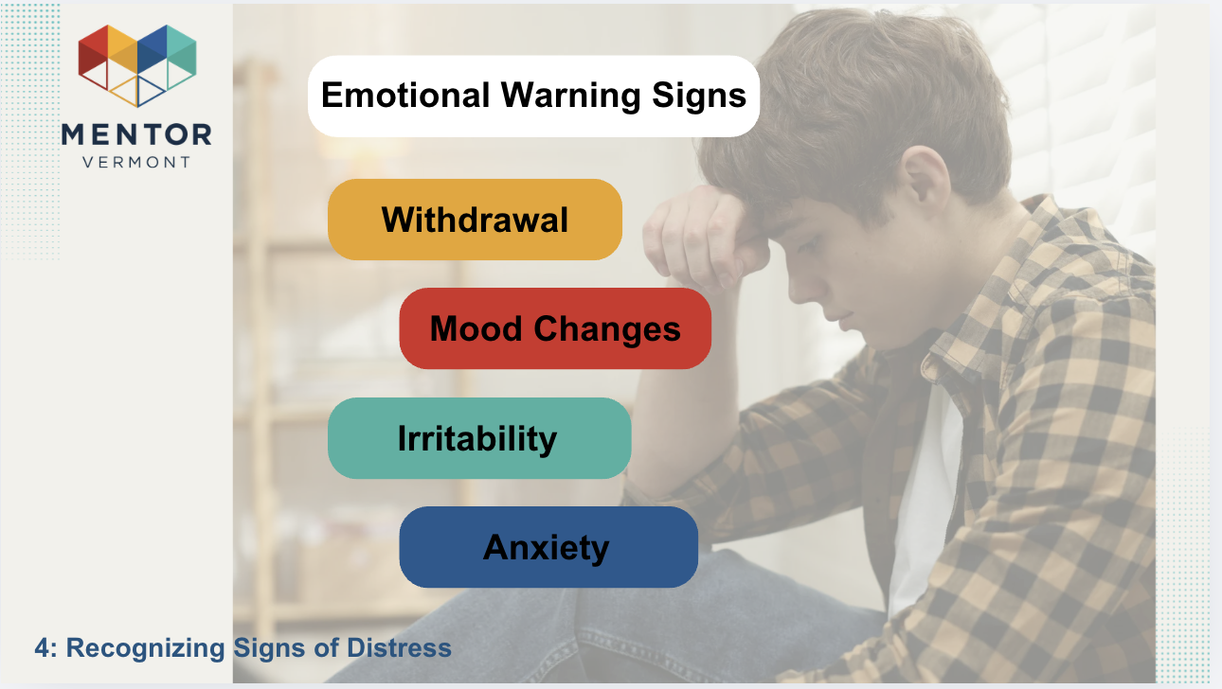 |  | Presentation slides | “These are signals, not diagnoses. Patterns matter more than single behaviors.”
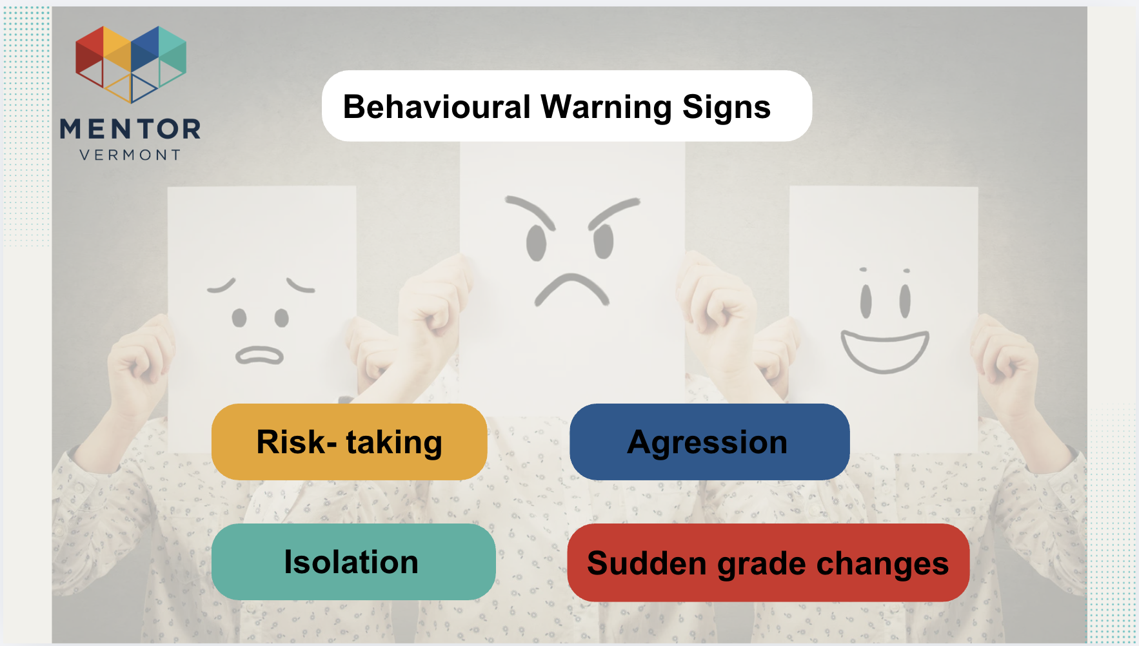 |  | Presentation slides | “Distress can also show up behaviorally — risk-taking, sudden grade changes, isolation, or aggression. Again, we’re looking for changes or escalation. Behavior is often communication. Instead of asking ‘What’s wrong with them?’ we ask, ‘What might be happening for them?’”
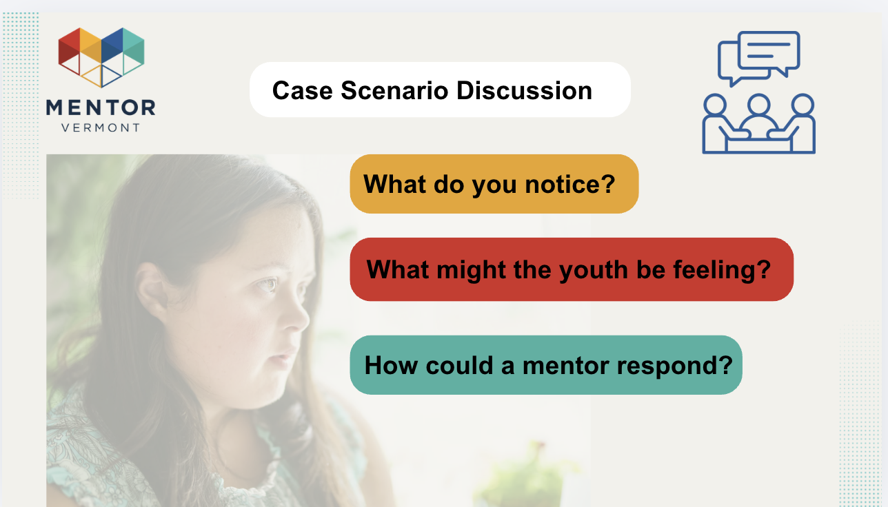 |  | Presentation slides | “Now let’s apply this. In your small groups, read the short scenario and discuss:  - What do you notice?  - What might the youth be feeling?  - How could a mentor respond?  Focus on observation and empathy — not problem-solving. We’ll debrief together in a few minutes.”
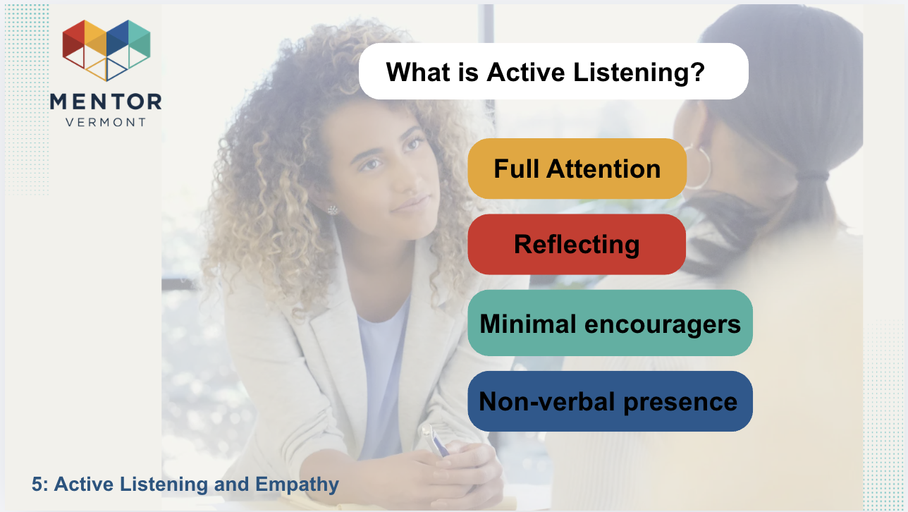 |  | Presentation slides, Chat feature | “Active listening means giving full attention — not planning your response. It includes reflecting back what you hear, using small encouragers like ‘mm-hm,’ and being fully present with your body language. Feeling heard is often more powerful than receiving advice.”
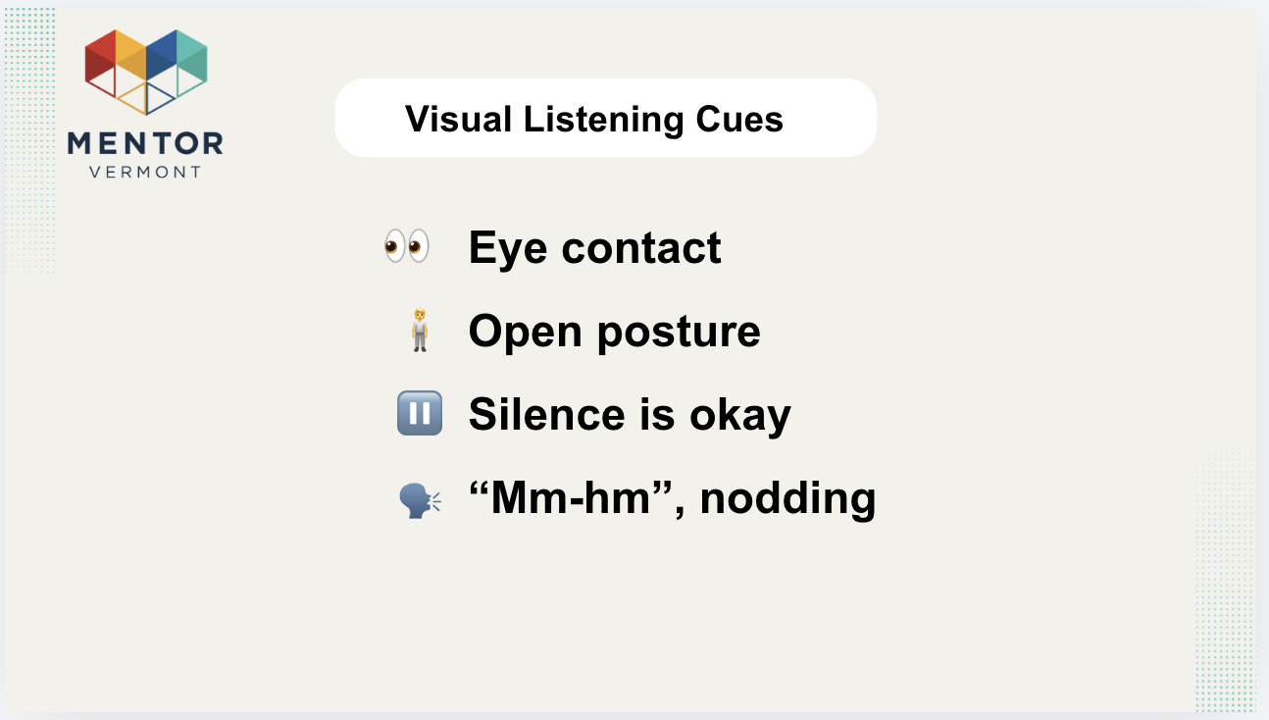 |  | Presentation slides | “Our non-verbal communication speaks loudly. Gentle eye contact, open posture, allowing silence, and nodding all signal safety. Silence can feel uncomfortable — but it often gives young people space to process.”
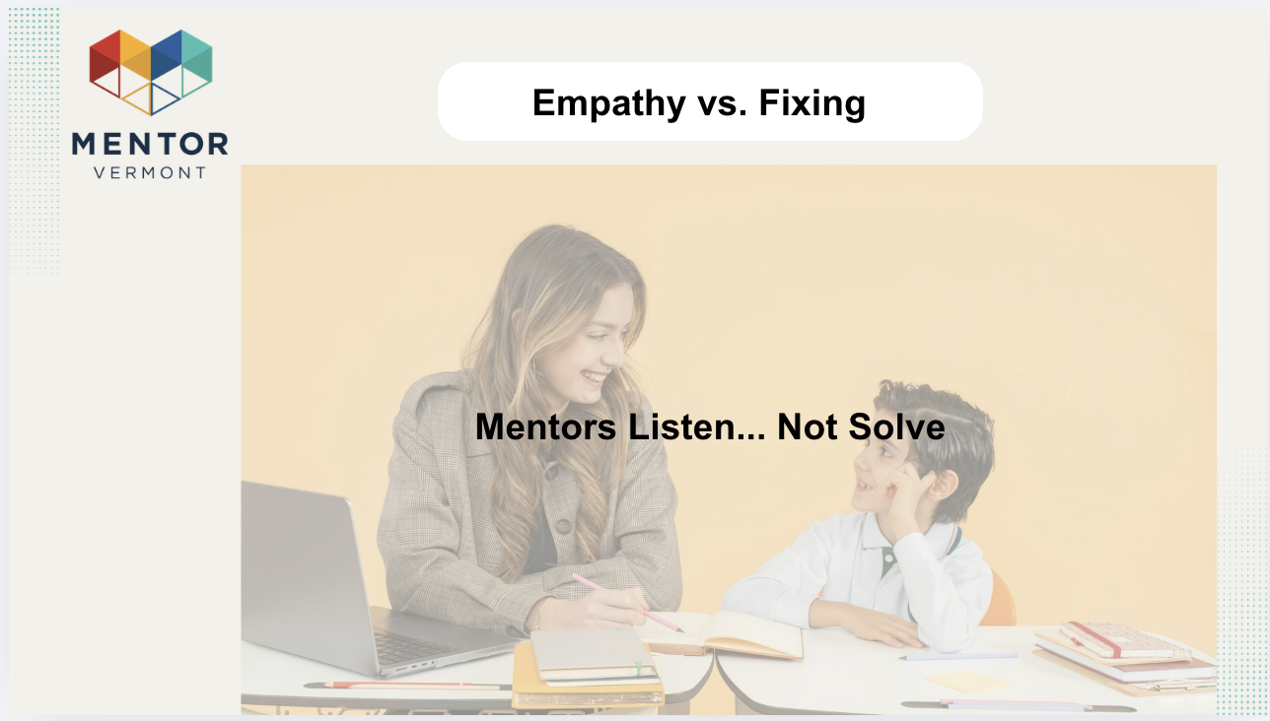 |  | Presentation slides | “This is key: mentors listen — they don’t fix. When youth share something hard, our instinct is to solve it. But connection comes before correction. Empathy builds trust. Fixing too quickly can unintentionally shut someone down.”
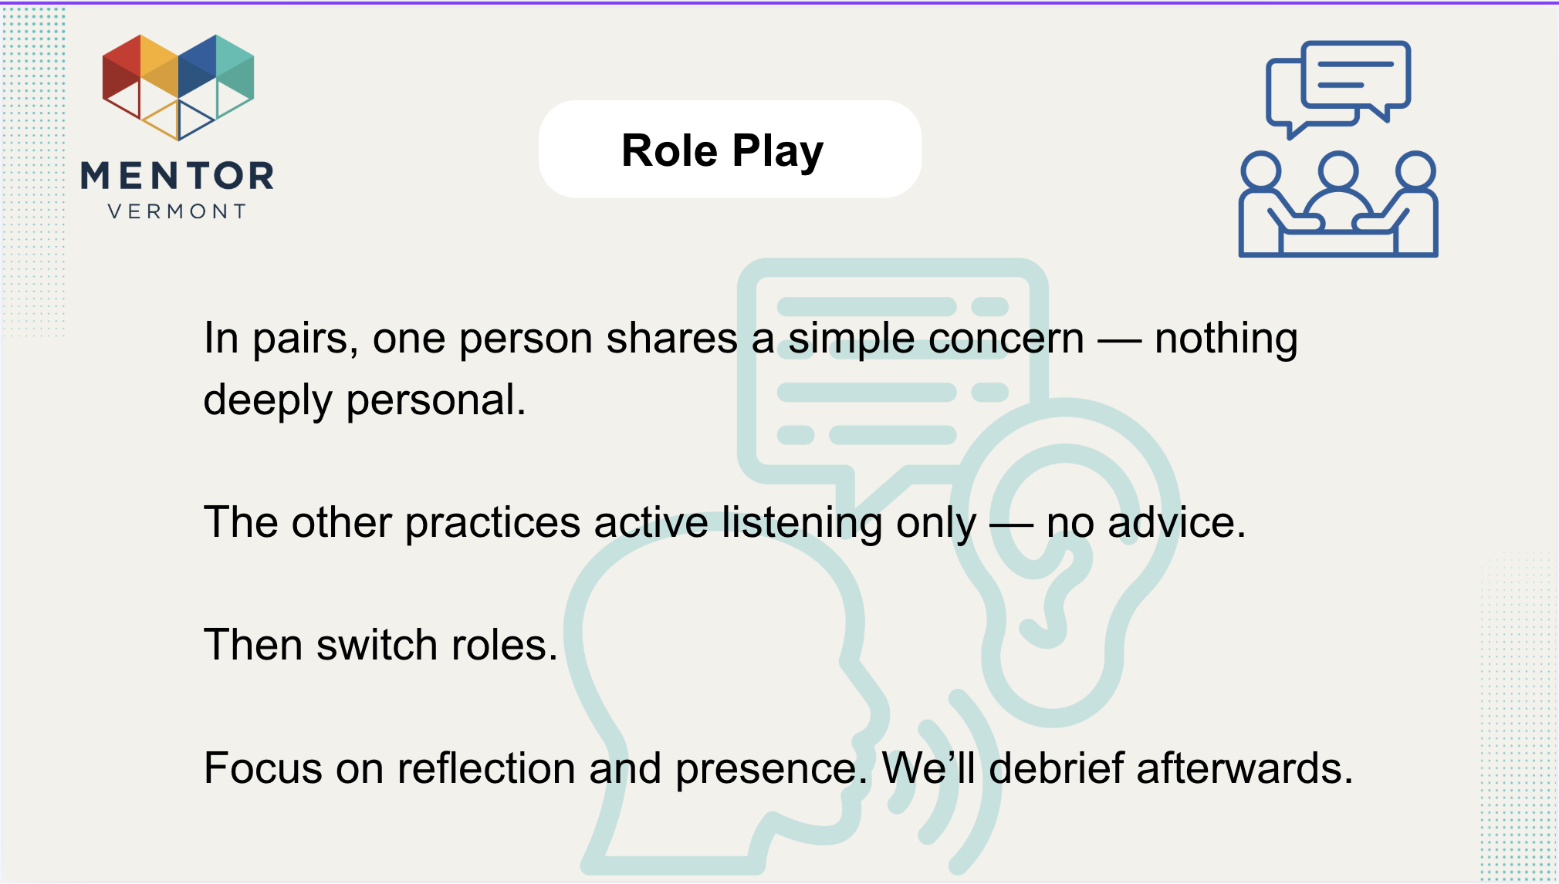 |  |  | “Now you’ll practice. In pairs, one person shares a simple concern — nothing deeply personal. The other practices active listening only — no advice. Then switch roles. Focus on reflection and presence. We’ll debrief afterward.”
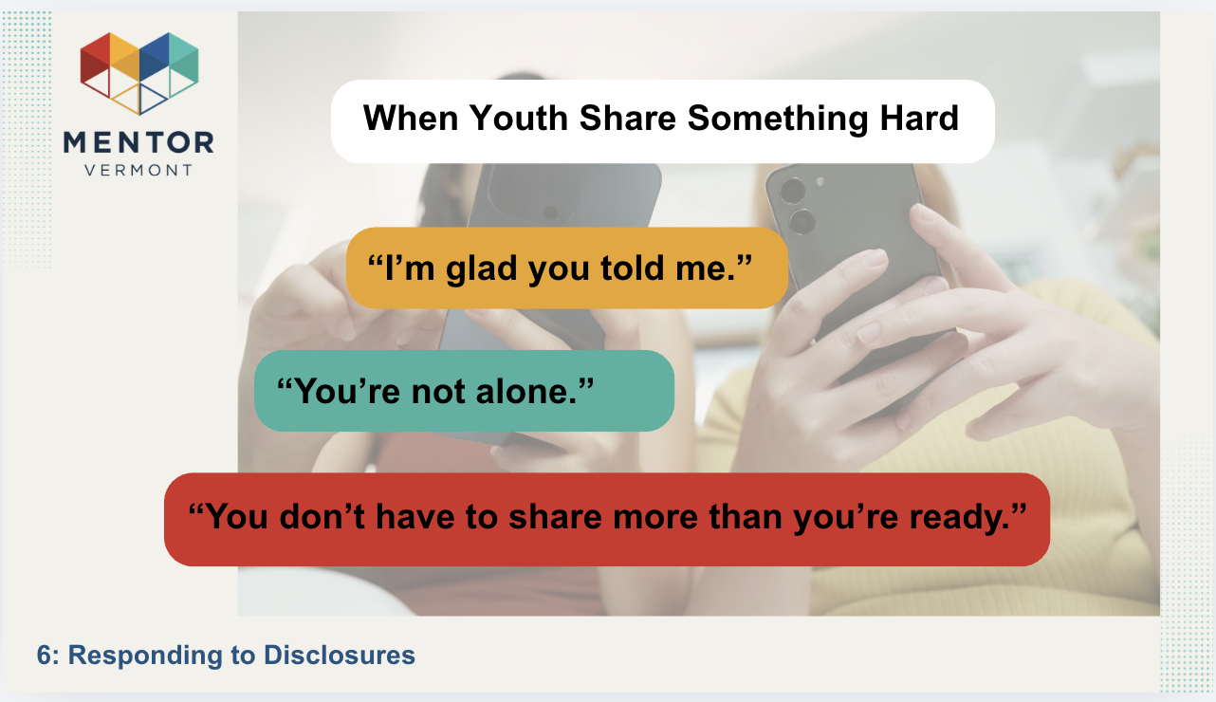 |  | Presentation slides | “When a young person shares something difficult, simple responses matter most. ‘I’m glad you told me.’ ‘You don’t have to share more than you’re ready.’ ‘You’re not alone.’ These statements create safety without pressure.”
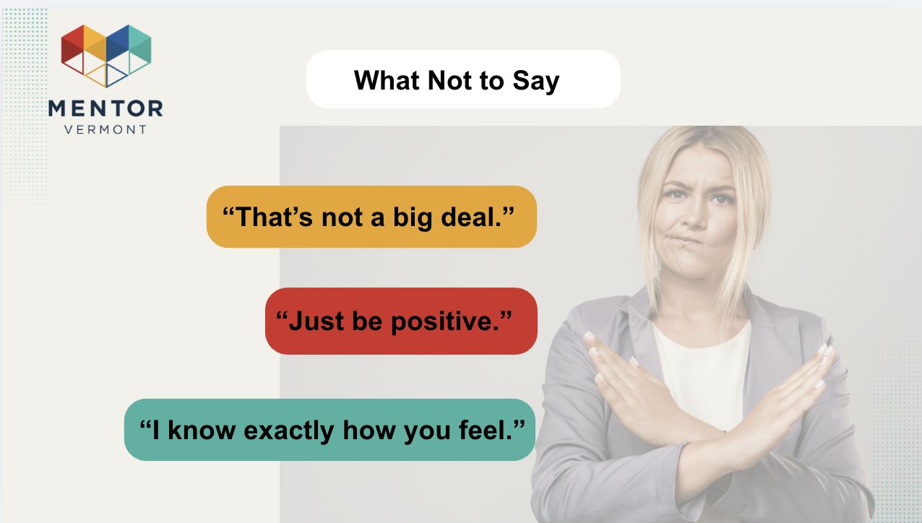 |  | Presentation slides | “Avoid minimizing or comparing. Statements like ‘That’s not a big deal,’ ‘Just be positive,’ or ‘I know exactly how you feel’ can unintentionally dismiss their experience. Even if well-intended, they may shut down trust.”
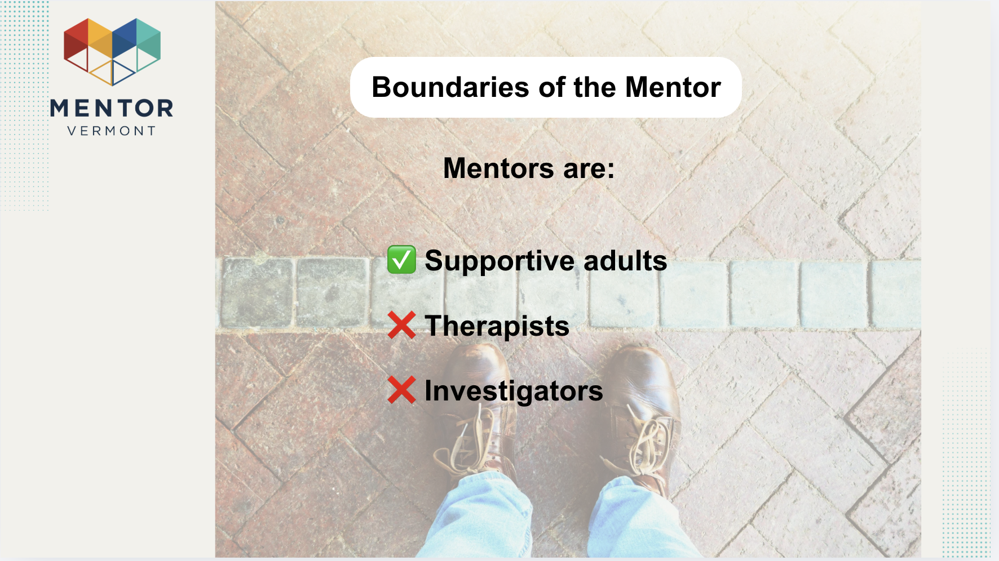 |  | Presentation slides | “Mentors are supportive adults — not therapists or investigators. Your role is to listen, care, and refer when necessary. You don’t need to diagnose, interrogate, or solve. Staying within your role protects both you and the youth.”
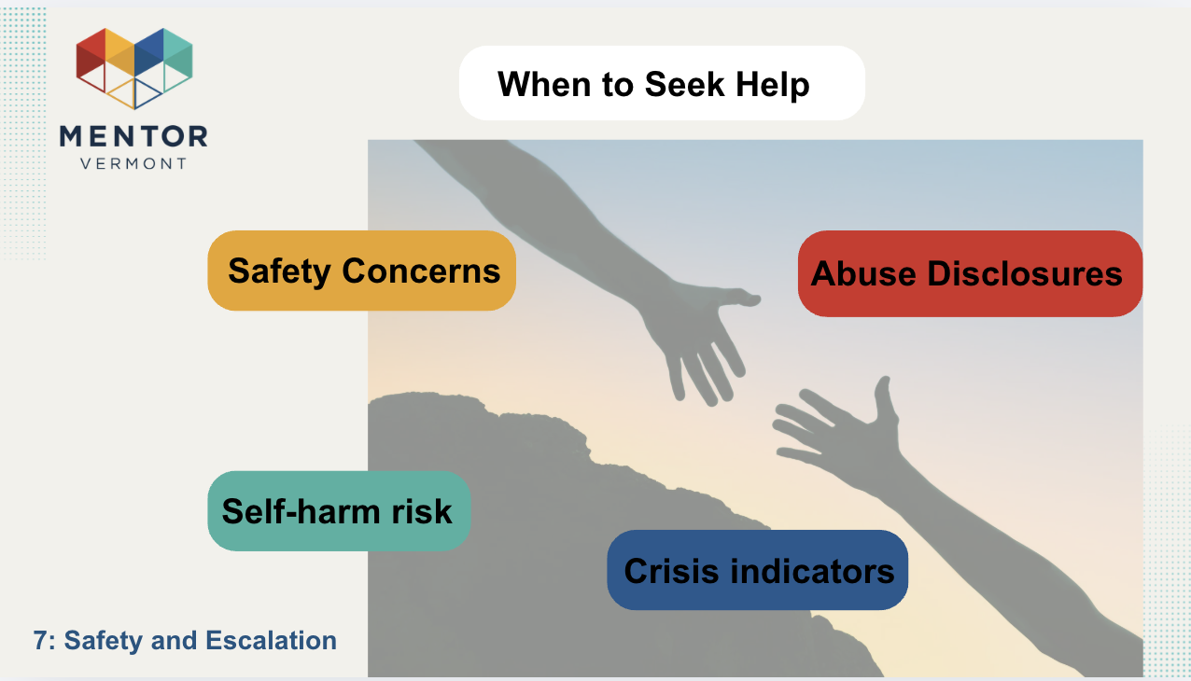 |  | Presentation slides | “Some situations require escalation — safety concerns, abuse disclosures, self-harm risk, or crisis indicators. When safety is at risk, connection alone isn’t enough. Seeking help is not overreacting — it’s responsible mentoring.”
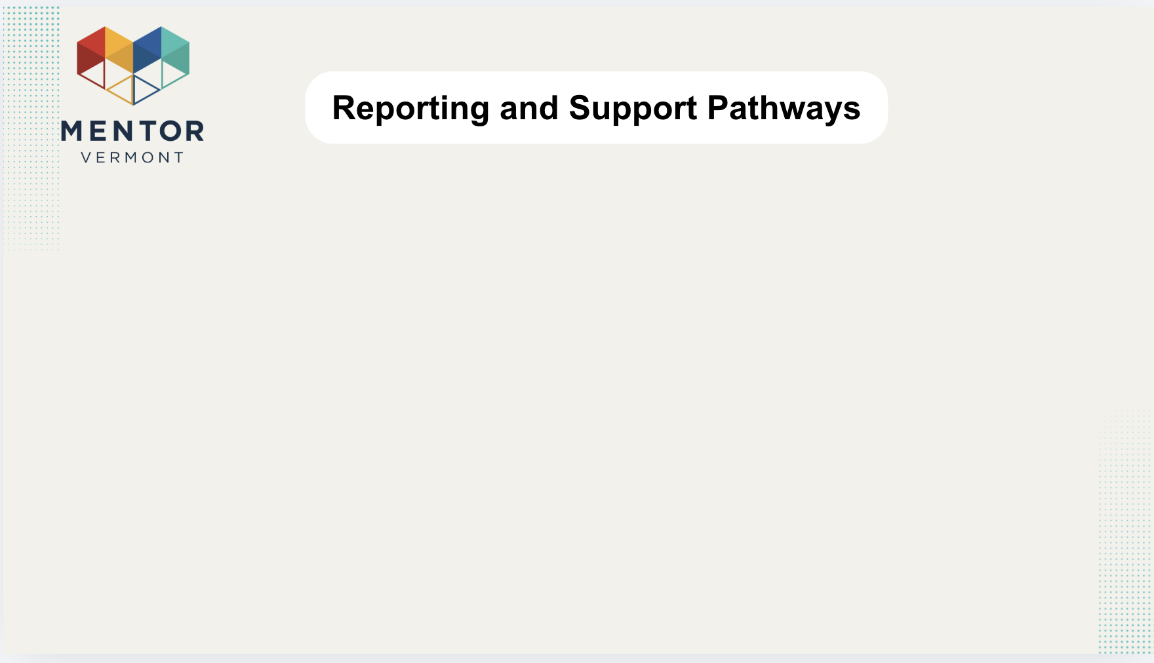 |  | Presentation slides | “Here’s the pathway: Mentor → Program Staff → Appropriate Services. You are never expected to handle serious concerns alone. Follow program protocol and document appropriately.”
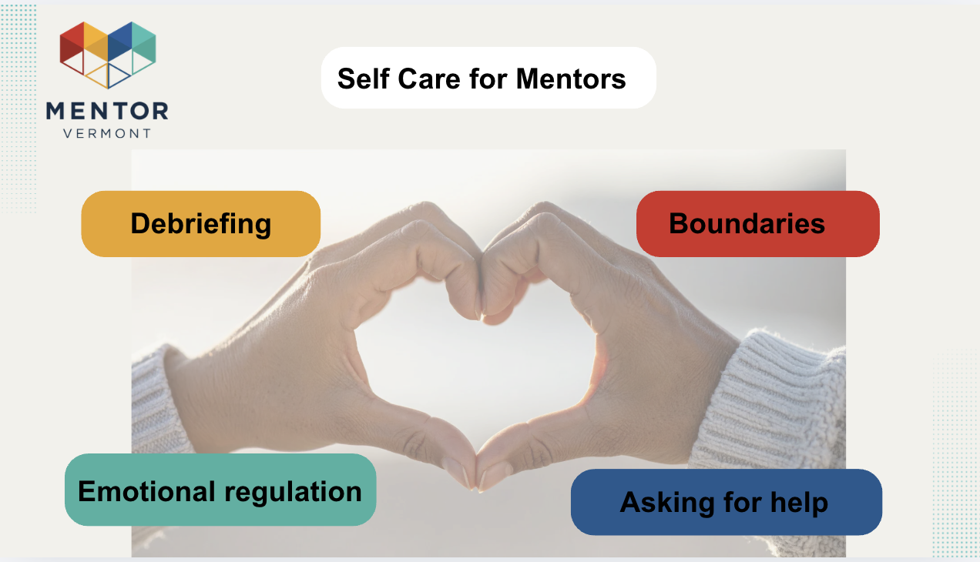 |  | Presentation slides | “Supporting youth can be emotionally heavy. Debrief when needed. Maintain boundaries. Practice emotional regulation. And ask for help. Taking care of yourself allows you to show up consistently and sustainably.”
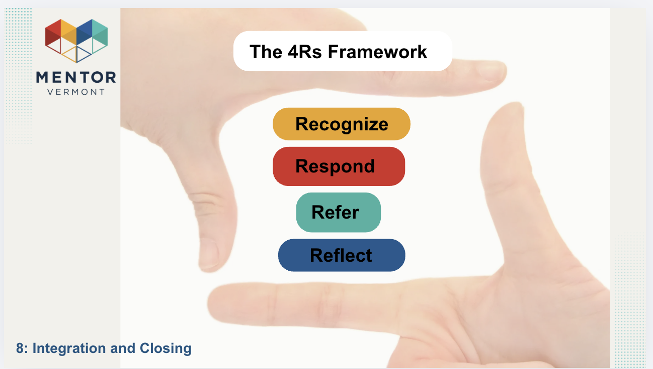 |  | Presentation slides | “To bring this together, remember the 4Rs:  Recognize signs of distress.  Respond with empathy.  Refer when safety is involved.  Reflect on your own practice.  This framework keeps mentoring clear and grounded.”
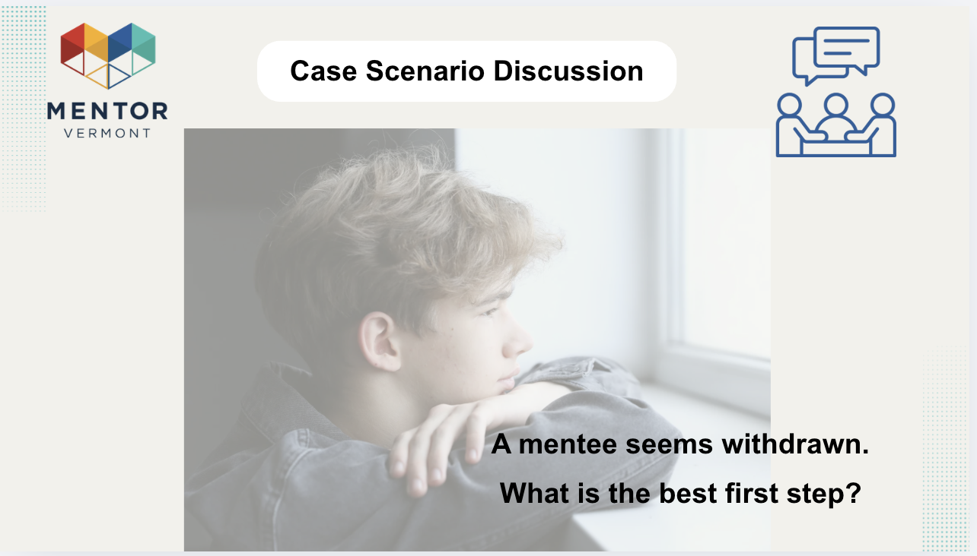 |  | Presentation slides | “A mentee seems withdrawn. Discuss with your partner what the best first step looks like.  Let's share our responses all together after.”
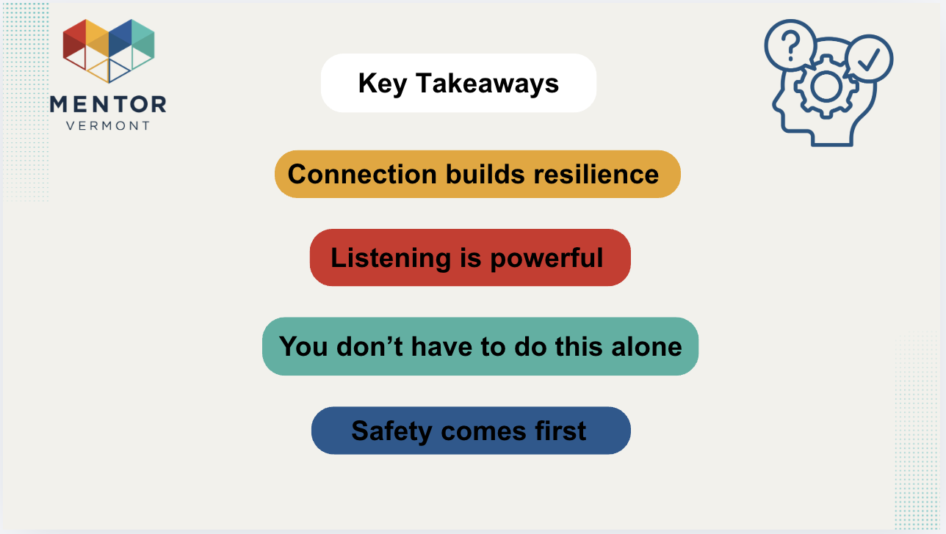 |  | Presentation slides | “Connection builds resilience. Listening is powerful. You don’t have to do this alone. And safety always comes first. If you remember nothing else — remember those four ideas.”
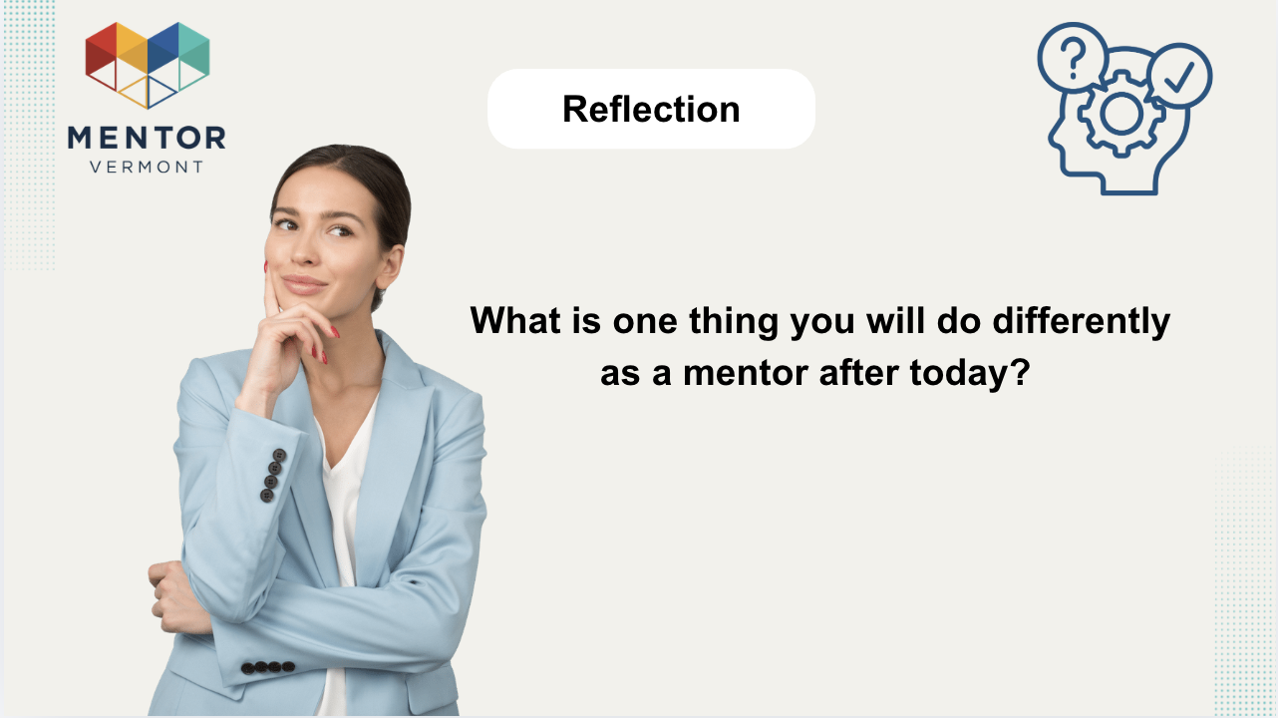 |  | Presentation slides | “Take a moment to reflect: What is one thing you will do differently as a mentor after today? You can write it down or simply hold it as an intention.”
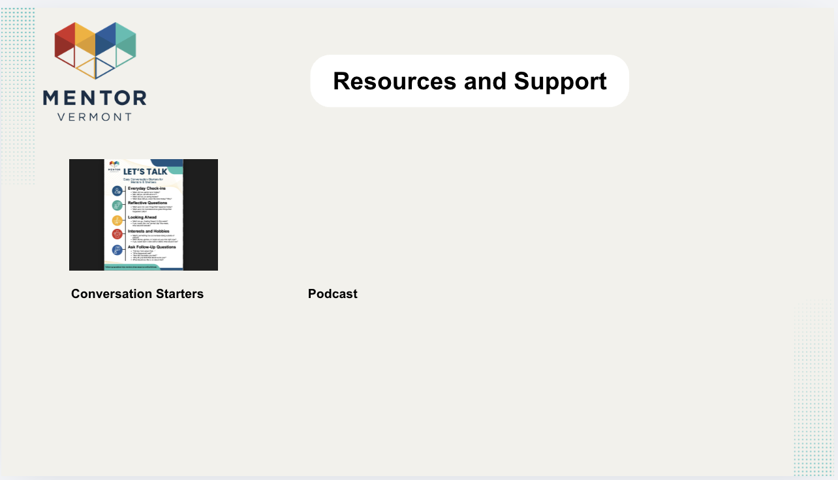 |  | Presentation slides
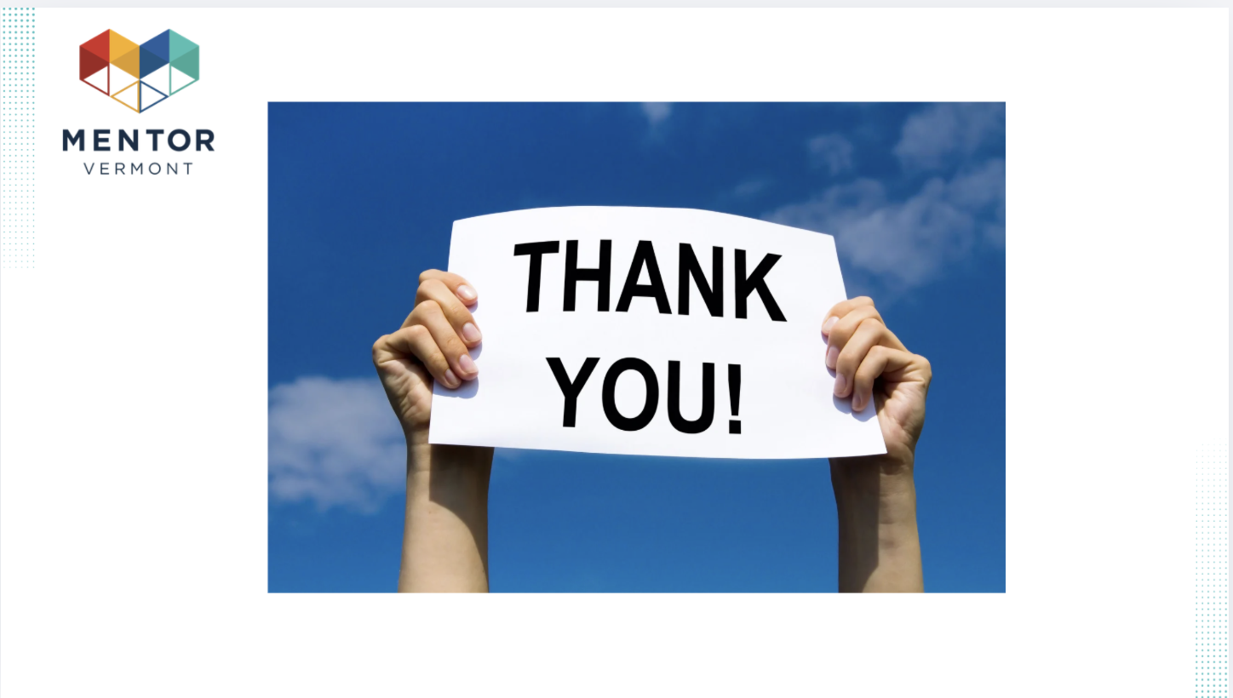 |  | Presentation slides | “Thank you for your presence and commitment to young people. Your willingness to listen and show up matters more than you know. We value your feedback; please let us know what you thought of today’s session. Now, let’s take some time for any questions you might have.”

Appendix A - Support

- Pre-Course Support:
  - Needs Assessment: Identify the knowledge gaps and learning needs of the participants.
  - Course Customization: Tailor the course content to meet the specific requirements of the audience.
  - Registration and Logistics: Provide information regarding course registration, schedule, and logistics.
  - Pre-course Material: Share any reading material, pre-assessments, or resources that the participants should go through before the training.
- Course Delivery Support:
  - Technical Support: Ensure that the participants have access to the necessary technical tools and support.
  - Interactive Content: Deliver the course using engaging and interactive content including videos, and discussions.
  - Real-time Assistance: Be available to provide real-time assistance and clarification during the course.
  - Facilitation Techniques: Use facilitation techniques to foster collaboration, group learning, and keep the audience engaged.
- Post-Course Support:
  - Resource Sharing: Provide participants with additional reading materials, case studies, or tools they can use to apply the learning.
  - Discussion Forums: Create online discussion forums or groups for participants to share experiences and learn from each other.
  - Access to Trainer: Provide the option for participants to reach out to the trainer or facilitator for any follow-up questions or clarifications.
- Post-Course Evaluation:
  - Feedback Surveys: Send out surveys to participants to get feedback on the course content, delivery, and overall experience.
  - Knowledge Assessments: Conduct post-course assessments to measure knowledge retention and learning outcomes.
  - Report and Analysis: Analyze the data from the feedback and assessments to understand the impact of the training and areas for improvement.
- Post-Course Follow-Up:
  - Action Plans: Encourage participants to create action plans on how they will apply the learnings in their work.
  - Check-ins: Schedule follow-up calls or meetings with participants to discuss their progress, challenges, and any further support needed.
  - Continued Learning: Suggest further courses or learning paths that participants can take to continue their development.

